## Customer Requirements Speciﬁcation

**SAG APP**

**ـــــــــــــــــــــــــــــــــــــــــــــــــــــــــــــــــــــــــــــــــــــــــــــــــــــــــــــــــــــــــــــــــــــــــــــــــــــــــــــــــــــــــــــــــــــــــــــــــــــــــــــــــــــــــــــــــــــــــــــــــــ**

**Table of Contents**

Document Status…………………………………………………………………. 1

Document History………………………………………………………………… 1

Reference Document……………………………………………………………. 2

Project Description………………………………………………………………. 3

# Document Status:

| **Name** | PO_SAG_CRS_APP |
| --- | --- |
| **Version** | V1.0 |
| **Status** | Proposed |
| **Author** | Aya Gamal |
| **Date** | [27-9-2022] |

# 

# 

# 

# 

# Document History:

| **Version** | **Author** | **Date** | **Change** |
| --- | --- | --- | --- |
| 1.0 | Ammar | [8-9-2021] | * Initial Creation * Add definition * Add features * Add Key elements * Add CRS Requirements |

# Reference Document:

| **Ref.number** | **Doc.Name** | **Version** | **Status** |
| --- | --- | --- | --- |
| 1 | PO_SAG_CR_APP | V1.0 | Released |

Project Description:

Definition:

The phone is used to make a complete connection between the glasses and the mobile phone , It also helps in making a quick connection and opening a specific app through the user's voice commands

Features:

* Mobile app to connect smart assistant glasses with personal mobile phone

Key Elements:

* User login to the app by id and initial password .
* Main screen shows a notification for permission to access some apps.
* Main screen shows instructions for using the glasses.
* User can search by text
* User can deal with settings Screen
* User can contact us through contact screen .
* User report and issue screen to solve any problem.

## System Context:

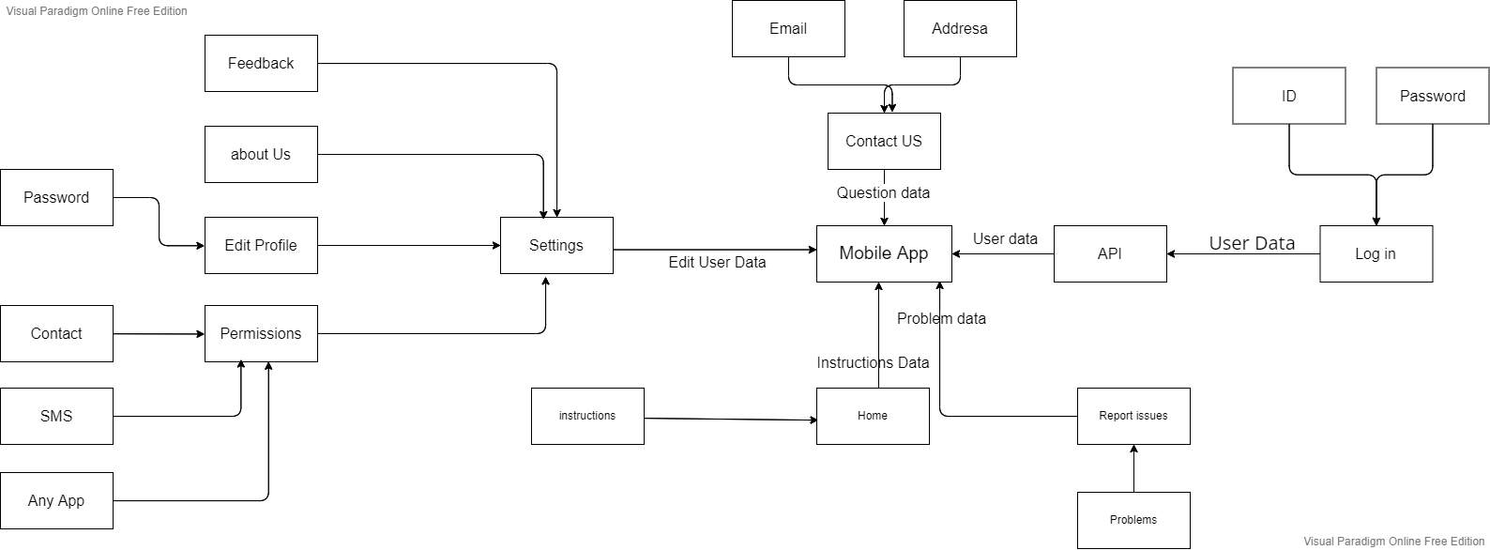

## CRS Requirements:

| **Req_ID** | Req_PO_SAG_CRS_***001***-V1.0 | **Covers** | Covers_PO_SAG_CR_APP_***001***-V1.1 |
| --- | --- | --- | --- |
| **Description** | User must have a SAG app to log in. | | |

| **Req_ID** | Req_PO_SAG_CRS_***002***-V1.0 | **Covers** | Covers_PO_SAG_CR_APP_***001***-V1.1 |
| --- | --- | --- | --- |
| **Description** | User can log in by id and initial password. | | |

| **Req_ID** | Req_PO_SAG_CRS_***003***-V1.0 | **Covers** | Covers_PO_SAG_CR_APP_***002***-V1.0 |
| --- | --- | --- | --- |
| **Description** | After log in , user should give SAG app some permissions | | |

| **Req_ID** | Req_PO_SAG_CRS_***004***-V1.0 | **Covers** | Covers_PO_SAG_CR_APP_***002***-V1.0 |
| --- | --- | --- | --- |
| **Description** | User should allow the SAG app to access contact information. | | |

| **Req_ID** | Req_PO_SAG_CRS_***005***-V1.0 | **Covers** | Covers_PO_SAG_CR_APP_***003***-V1.1 |
| --- | --- | --- | --- |
| **Description** | The main Screen shows how to use the application. | | |

| **Req_ID** | Req_PO_SAG_CRS_***006***-V1.0 | **Covers** | Covers_PO_SAG_CR_APP_***004***-V1.1 |
| --- | --- | --- | --- |
| **Description** | User can deal with settings Screen | | |

| **Req_ID** | Req_PO_SAG_CRS_***007***-V1.0 | **Covers** | Covers_PO_SAG_CR_APP_***004***-V1.1 |
| --- | --- | --- | --- |
| **Description** | User can edit his profile through settings | | |

| **Req_ID** | Req_PO_SAG_CRS_***008***-V1.0 | **Covers** | Covers_PO_SAG_CR_APP_***004***-V1.1 |
| --- | --- | --- | --- |
| **Description** | User can change personal information. | | |

| **Req_ID** | Req_PO_SAG_CRS_***09***-V1.0 | **Covers** | Covers_PO_SAG_CR_APP_***004***-V1.0 |
| --- | --- | --- | --- |
| **Description** | User views about us page through settings. | | |

| **Req_ID** | Req_PO_SAG_CRS_***010***-V1.0 | **Covers** | Covers_PO_SAG_CR_APP_***004***-V1.0 |
| --- | --- | --- | --- |
| **Description** | User can see more information about product. | | |

| **Req_ID** | Req_PO_SAG_CRS_***011***-V1.0 | **Covers** | Covers_PO_SAG_CR_APP_***004***-V1.1 |
| --- | --- | --- | --- |
| **Description** | User can edit accessed apps through settings. | | |

| **Req_ID** | Req_PO_SAG_CRS_***013***-V1.0 | **Covers** | Covers_PO_SAG_CR_APP_***004***-V1.0 |
| --- | --- | --- | --- |
| **Description** | User can send feedback through settings. | | |

| **Req_ID** | Req_PO_SAG_CRS_***014***-V1.0 | **Covers** | Covers_PO_SAG_CR_APP_***004***-V1.0 |
| --- | --- | --- | --- |
| **Description** | User can log out through settings. | | |

| **Req_ID** | Req_PO_SAG_CRS_***015***-V1. | **Covers** | Covers_PO_SAG_CR_APP_***004***-V1.1 |
| --- | --- | --- | --- |
| **Description** | User can contact us through contact screen | | |

| **Req_ID** | Req_PO_SAG_CRS_***016***-V1.0 | **Covers** | Covers_PO_SAG_CR_***005***-V1.1 |
| --- | --- | --- | --- |
| **Description** | User can contact us by sending email | | |

| **Req_ID** | Req_PO_SAG_CRS_***017***-V1.0 | **Covers** | Covers_PO_SAG_CR_***006***-V1.1 |
| --- | --- | --- | --- |
| **Description** | User report and issue screen to solve any problem. | | |